**Q1: Can you create a simple HTML table to display a list of items with basic styling using CSS?**

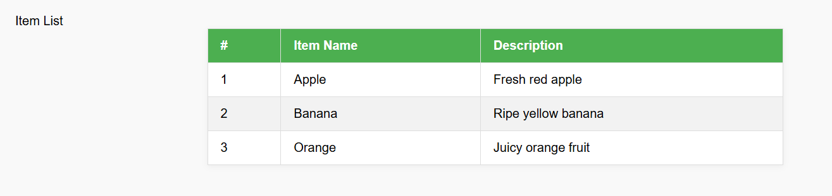

<!DOCTYPE html>

<html lang="en">

<head>

<meta charset="UTF-8">

<title>Simple Styled Table</title>

<style>

body {

font-family: Arial, sans-serif;

margin: 40px;

background: #f9f9f9;

}

table {

border-collapse: collapse;

width: 60%;

margin: auto;

background: #fff;

box-shadow: 0 2px 8px rgba(0,0,0,0.05);

}

th, td {

border: 1px solid #ddd;

padding: 12px 16px;

text-align: left;

}

th {

background-color: #4CAF50;

color: white;

}

tr:nth-child(even) {

background-color: #f2f2f2;

}

tr:hover {

background-color: #e0f7fa;

}

caption {

caption-side: top;

font-size: 1.3em;

margin-bottom: 10px;

font-weight: bold;

}

</style>

</head>

<body>

<table>

<caption>Item List</caption>

<thead>

<tr>

<th>#</th>

<th>Item Name</th>

<th>Description</th>

</tr>

</thead>

<tbody>

<tr>

<td>1</td>

<td>Apple</td>

<td>Fresh red apple</td>

</tr>

<tr>

<td>2</td>

<td>Banana</td>

<td>Ripe yellow banana</td>

</tr>

<tr>

<td>3</td>

<td>Orange</td>

<td>Juicy orange fruit</td>

</tr>

</tbody>

</table>

</body>

</html>

**Q2: Build a styled HTML table with CSS and add a JavaScript toggle button to show or hide the data.**

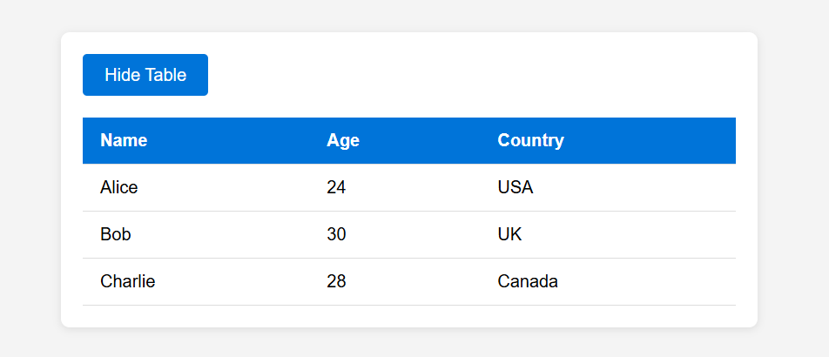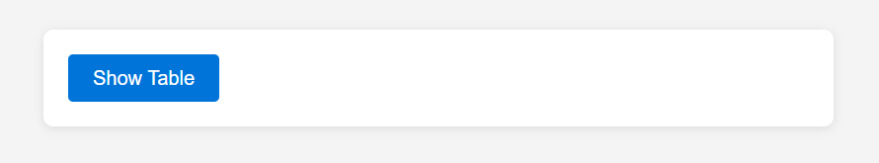

<!DOCTYPE html>

<html lang="en">

<head>

<meta charset="UTF-8">

<meta name="viewport" content="width=device-width, initial-scale=1.0">

<title>Styled Table with Toggle</title>

<style>

body {

font-family: Arial, sans-serif;

background: #f4f4f4;

padding: 40px;

}

.container {

max-width: 600px;

margin: auto;

background: #fff;

padding: 20px;

border-radius: 8px;

box-shadow: 0 2px 8px rgba(0,0,0,0.1);

}

table {

width: 100%;

border-collapse: collapse;

margin-top: 20px;

}

th, td {

padding: 12px 16px;

border-bottom: 1px solid #ddd;

text-align: left;

}

th {

background: #0074D9;

color: #fff;

}

tr:hover {

background: #f1f1f1;

}

button {

background: #0074D9;

color: #fff;

border: none;

padding: 10px 20px;

border-radius: 4px;

cursor: pointer;

font-size: 16px;

transition: background 0.2s;

}

button:hover {

background: #005fa3;

}

</style>

</head>

<body>

<div class="container">

<button id="toggleBtn">Hide Table</button>

<table id="dataTable">

<thead>

<tr>

<th>Name</th>

<th>Age</th>

<th>Country</th>

</tr>

</thead>

<tbody>

<tr>

<td>Alice</td>

<td>24</td>

<td>USA</td>

</tr>

<tr>

<td>Bob</td>

<td>30</td>

<td>UK</td>

</tr>

<tr>

<td>Charlie</td>

<td>28</td>

<td>Canada</td>

</tr>

</tbody>

</table>

</div>

<script>

const toggleBtn = document.getElementById('toggleBtn');

const dataTable = document.getElementById('dataTable');

let visible = true;

toggleBtn.addEventListener('click', () => {

visible = !visible;

dataTable.style.display = visible ? '' : 'none';

toggleBtn.textContent = visible ? 'Hide Table' : 'Show Table';

});

</script>

</body>

</html>

**Q3: Create a responsive HTML, CSS, and JavaScript component that only displays data when a user with permission clicks a 'Show Data' button. Include a message if the user is not authorized.**

**Información adicional: In one file.**

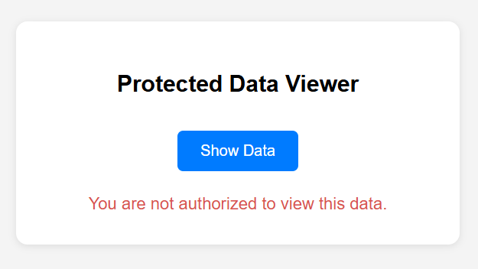

<!DOCTYPE html>

<html lang="en">

<head>

<meta charset="UTF-8">

<meta name="viewport" content="width=device-width, initial-scale=1.0">

<title>Show Data Component</title>

<style>

body {

font-family: Arial, sans-serif;

background: #f4f4f4;

margin: 0;

padding: 0;

display: flex;

justify-content: center;

align-items: center;

height: 100vh;

}

.container {

background: #fff;

padding: 2rem;

border-radius: 12px;

box-shadow: 0 2px 8px rgba(0,0,0,0.1);

max-width: 400px;

width: 100%;

text-align: center;

}

button {

background: #007bff;

color: #fff;

border: none;

padding: 0.75rem 1.5rem;

border-radius: 6px;

font-size: 1rem;

cursor: pointer;

transition: background 0.2s;

margin-top: 1rem;

}

button:hover {

background: #0056b3;

}

.message {

margin-top: 1.5rem;

font-size: 1.1rem;

color: #d9534f;

}

.data {

margin-top: 1.5rem;

font-size: 1.1rem;

color: #28a745;

word-break: break-word;

}

@media (max-width: 500px) {

.container {

padding: 1rem;

max-width: 95vw;

}

button {

width: 100%;

}

}

</style>

</head>

<body>

<div class="container">

<h2>Protected Data Viewer</h2>

<button id="showDataBtn">Show Data</button>

<div id="output"></div>

</div>

<script>

// Simulate user permission (set to true or false)

const userHasPermission = false; // Change to true to simulate authorized user

const dataToShow = "Here is your secret data: 42, Alpha, Beta, Gamma.";

document.getElementById('showDataBtn').addEventListener('click', function() {

const output = document.getElementById('output');

output.innerHTML = '';

if (userHasPermission) {

output.innerHTML = `<div class='data'>${dataToShow}</div>`;

} else {

output.innerHTML = `<div class='message'>You are not authorized to view this data.</div>`;

}

});

</script>

</body>

</html>